Hosea
The Loyal Husband

Introduction

History

Timeline (B.C.)
808 The Prophet ELISHA died.
798 JOASH died, succeeded by his son JEROBOAM, who had ruled for 11 years as co-regent with his father, in the 15th year of AMAZIAH’S reign. He ruled Israel 41 years. AMOS, father of ISAIAH, prophesied to 747 B.C. and wrote “Amos” during the reign of JEROBOAM in Israel and UZZIAH in Judah.
Figure 1: Hosea and Jonah by Raphael, c. 1510
786 The Great Earthquake of AMOS 1 destroyed Tyre, Sidon, Ashdod, from Damascus to Gaza.
784 AMAZIAH died, succeeded by his son AZARIAH (UZZIAH), age 16, in the 27th year of JEROBOAM’S reign. His mother was JECHOLIAH of Jerusalem. He ruled Judah 52 years.
776 The first Olympiad was held in Greece.
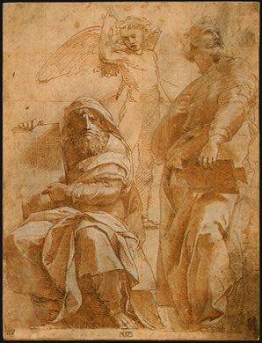
772 JONAH prophesied to the Assyrians at Nineveh, and “Jonah” was written.
761 JEROBOAM died, succeeded by his son ZACHARIAH who ruled Israel 6 months in the 38th year of UZZIAH’S reign. He was slain by SHALLUM, son of JABESH, who ruled Israel 1 month. SHALLUM was slain by MENAHEM, son of GADI, who ruled Israel 10 years in an overlapping reign with PEKAH.
753 Rome was founded and Roman dating began.
750 MENAHEM died, succeeded by his son PEKAHIAH, in the 50th year of UZZIAH’S reign. He ruled a two-year overlapping reign with PEKAH in Israel. HOSEA prophesied.
748 PEKAHIAH of Israel was slain by PEKAH in the 52nd year of UZZIAH’S reign, and PEKAH ruled Israel alone for 20 years.
747 UZZIAH was stricken with leprosy and his son JOTHAM, age 25, ruled as co-regent over Judah, in the 2nd year of PEKAH’S reign. He ruled Judah 16 years. His mother was JERUSHA, daughter of ZADOK.
740 ISAIAH began to prophesy.
738 Assyria conquered Hamath.
734 The Assyrians took Damascus of Syria and invaded Israel.
732 King UZZIAH of Judah died. His son JOTHAM also died, succeeded by his son AHAZ, age 20, in the 17th year of PEKAH’S reign. He ruled Judah 16 years.
731 Babylon was conquered by the Assyrians.
730 MICAH prophesied.
729 PEKAH was slain by HOSHEA, son of ELAH. HOSHEA ruled Israel 9 years and was ruling when Israel went into Assyrian captivity.
727 HEZEKIAH became co-regent with his father AHAZ, in the 3rd year of HOSHEA’S reign.
726 Israel revolted against Assyria.
724 HEZEKIAH destroyed the brazen serpent Moses had made.
721 In the 9th year of HOSHEA of Israel and the 6th year of HEZEKIAH’S reign as vice-regent with his father AHAZ, Israel was taken captive by Assyria. 27,290 captives were deported from Samaria to Gozan, Harran, Media, Hulah and Nineveh.
717 AHAZ died, succeeded by his son HEZEKIAH. His mother was ABIJAH, daughter of ZECHARIAH. He ruled Judah 29 years.
710 HEZEKIAH’S tunnel was built to bring water into Jerusalem.
697 HEZEKIAH died, succeeded by his son MANASSEH, age 12. His mother was HEPHZIBAH. He ruled Judah 55 years. The Prophet ISAIAH died. He wrote “Isaiah” during the reigns of UZZIAH, JOTHAM, AHAZ and HEZEKIAH covering 784- 697 B.C. The Prophet HOSEA wrote “Hosea”, covering 784- 697 B.C. The Prophet MICAH wrote “Micah” covering 747- 697 B.C.
664 The first naval battle occurred between Corinth and Corcyra.
Figure 2: Hosea, Hie vahet an das Register uber die bibeln des alten testaments, 1477
642 MANASSEH died, succeeded by his son AMON, age 22. His mother was MESHULLEMETH, daughter of HARUZ of Jotbah. He ruled Judah 2 years. The Prophet NAHUM wrote “Nahum” during his reign, covering 697-642 B.C.

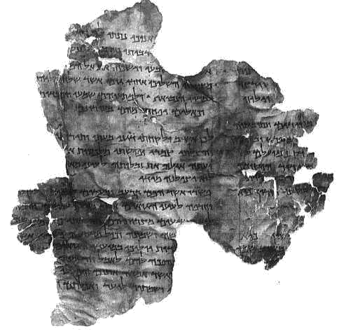
Authenticity

Universal Acceptance in Early Church

St. Paul quotes (Rom 9:25)

Matthew quoted Hosea (Matt 2:15)

Author

Name means “Help” or “Deliverance”
Figure 2: Fragment of Commentary on Hosea from the Dead Sea Scrolls

Son of “Beeri” (1:1)

Not mentioned by name elsewhere in Old Testament

Theme/Purpose: God’s loyal love for Israel

Setting

Northern Kingdom (5:1, 7:5)

During this time, six kings reigned in 25 years, which causes tremendous social and economic upheaval

Primary Characters

God: The loving Husband Whose bride is unfaithful, but He takes her back

Hosea: His life serves as a symbol of God’s marriage to the church

Gomer: Hosea’s wife (“A bride of adultery”), represents adulterous Israel

Hosea’s children: Represent Israel as a whole

Jezreel: “God scatters”

Lo-Ruchamah: “She is not pitied”

Lo-Ammi: “Not My people”

Preliminary Questions

How is Hosea’s time like ours?

How is Hosea’s message particularly applicable to our daily lives?

Why is Hosea relevant to all eras of God’s people?

The Text
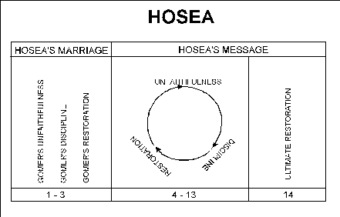
Figure 3: A Visual Outline of Hosea

The Adulterous Wife and Faithful Husband (1:1–3:5)

The Introduction to the Book of Hosea (1:1)

What does the first verse tell us about the authority of this text?

The Prophetic Marriage of Hosea and Gomer (1:2-2:1)
Figure 4: Hosea & Gomer, Catholic Geman Bible, Dietenberger, 1534

Hosea’s Marriage to Gomer (1:2)

How is our relationship with God like a marriage? (cf. Eph 5:21-33)

How is idolatry like adultery? (1:2)

Note: Gomer may not have been a harlot per se, but probably participated in the “fertility cult” of Baal. Regardless, she was impure at her marriage to Hosea.

How does Hosea’s marriage to a known adulteress speak to today’s marriage and divorce practice?

How does Hosea’s attitude toward his wife show God’s love to us?

The Children of Hosea and Gomer (1:3-9)

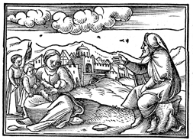
If Gomer represents Israel, what do the children represent?
Figure 5: Hosea, Gomer, & Three Children, Zurich Bible, 1536

How would expecting Hosea to raise a child as his own represent an idolatrous nation’s request of the same to God?

What is the significance of the name Jezreel? (1:4) (cf. 1 Kings 21)

Why would God stop having pity on someone? (1:6) Does this mean God’s forgiveness has limits?

Why did God have pity on Judah? (1:7)

How did Hosea know how God would save Judah? (2 Chron 32:1-23) Note that this prophecy (the naming of his child) was done roughly 60 years before its fulfillment, even if the book was not entirely written until after the fact.

Compare 1:8-9 with 1 Thess 2:14-16. How does Judah compare to Israel?

The Application of Future Restoration (1:10-2:1)

Did God keep His promise to multiply the children of Israel? (1:10-11)

How can someone be “forever rejected” but still pitied? (2:1)

Who is the “one head” of Israel? (1:11)

Compare 2:3 with Romans 15:7-13.

The Application of the Adultery of Gomer (2:2-23)

Israel’s Sin of Spiritual Adultery (2:2-5)

In what way does our “mother” (the Christian church) need chiding? How can we chide our mother?

For what purpose would God “strip her naked…and slay her with thirst” (cf. Lev 26:14-39)?

Who are Israel’s lovers? (2:5)

How are Christians tempted to “go after” different lovers?

What lovers does the Christian church “go after”?

What “bread…wool…flax…etc.” might Christians seem to gain by going after these lovers?

Judgment of God (2:6-13)

While unfaithfulness can give temporary pleasure, does it satisfy? (2:6-7) How does God give an alternative?

Why does God sometimes put obstacles in our lives?

What parable does 2:7 remind you of?

Who is the giver of all good gifts? (2:8) What are some ways we don’t give credit where credit is due?

Should God choose discipline for us, can anyone save us from that suffering? Is this good or bad?

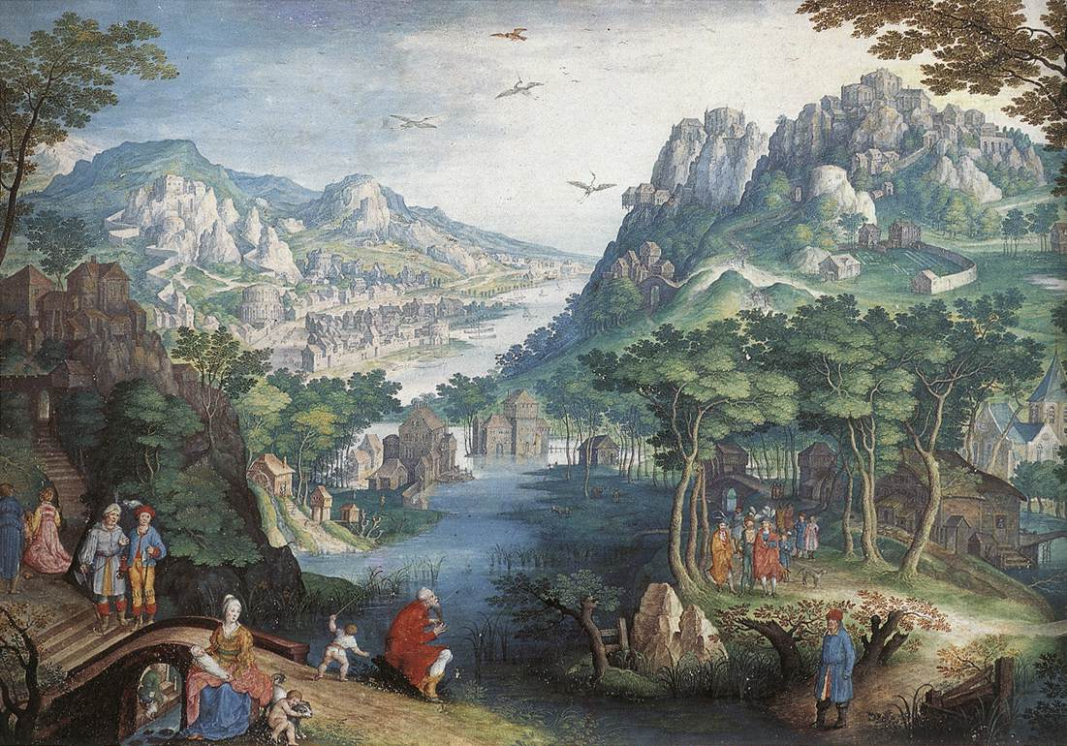
How do our holiday celebrations differ from their original intent? (2:11)

Restoration of Israel (2:14-23)
Figure 6: Mountain Landscape with River Valley and the Prophet Hosea, Gillis van Coninxloo, c. 1600

What does Israel do to gain God’s favor back?

Note in v. 16 that “Baal” means “lord,” a play on words. How is a husband different from a lord?

Would you trust an adulterous spouse who continues to spend time with a former adulterer? How is this like our relationship with God? (2:17)

How does God make his spouse faithful again?

How does 2:18 look forward to the New Creation? (cf. Isa 11:6-8)

How are we betrothed to God? (2:18-19) When was/is the wedding?

What is the basis of God’s betrothal to us?

How does God sow us to Him? (2:23)

The Restoration of Gomer to Hosea (3:1-5)

What does it mean that Hosea “bought” Gomer? How is this like God?

How is barley like the Christian life?

To what “afterward” is Hosea referring in 3:5?

The Adulterous Israel and Faithful Lord (4:1-14:9)

The Spiritual Adultery of Israel (4:1-6:3)

The Sins of Israel (4:1-19)

Rejection of the Knowledge of God (4:1-10)

What pollutes the land that causes God to enact a lawsuit against Israel? (4:1-2)

Some consider our country a “Christian Nation.” How would our land hold up in comparison to the description of Israel here?

How are the “beasts, birds, and fish” affected by sin? (cf. Gen 3:17-18)

Do 2:4 and 4:4 contradict each other? Why the reversal?

In which cases should we apply 2:4 and when should 4:4 apply to us?

Did God destroy their “mother,” Israel? (4:5)
Figure 7: Hosea 4:6

What does 4:6 tell us about the importance of Bible study and catechesis?

What does the removal of the Levitical priesthood mean? (4:6)

In what way did the priests “feed on the sins of the people”? (4:8)

Idolatry of Israel (4:12-19)

What are some common forms of divination (4:12) used today? Where does God want us to find answers?

Does it matter where to offer sacrifices? (4:13)

Why does God not need to step in to punish these sins? (4:14) Have you seen this in modern times?

Why would God not want them to use the oath, “As Yahweh lives”?

Why can’t the Lord pasture stubborn people?

How is the description in 4:18 like a drug addict? How is sin addictive?

What is the end of all sin? (4:19)

Judgment of Israel (5:1-14)

Who are singled out for punishment in 5:1? Why?

According to 5:4, what keeps sinners from returning to God? Have you ever found it easier to lie or avoid being confronted rather than just admit your sin? Was it really easier?

In 5:4, if they are worshiping an idol, why is Yahweh still called “their God”?

Why is pride (5:5) a sin?

In 5:4, He is still “their God,” but in 5:6, they won’t find Him no matter what. Why not?

How did they deal “treacherously” with Yahweh? (5:7) How does this speak to postmodern universalism?

Why are their children “aliens”?

According to 5:8-9, what is their punishment?

Why is Judah punished? (5:10)

What did Ephraim “walk after”?

What do moth and rottenness do to them? (q.v. 5:7)

Eventual Restoration of Israel (5:15-6:3)

How is God in 5:15 like the father in the prodigal son parable? (Luke 15:20)

In 6:1, the objective pronouns are missing from the first half of each sentence. [“Come, and let us return unto Jehovah; for he hath torn (whom?), and he will heal us; he hath smitten (whom?), and he will bind us up.” (Hos. 6:1, ASV)].

6:2 has fulfillment in both the Old Testament and New. In the immediate context, it refers to a short period of suffering. What is the New Testament fulfillment?

The Refusal of Israel to Repent of Her Adultery (6:4-8:14)

Willful Transgression of the Covenant (6:4-11)

How are God and His people contrasted in 6:3-4?

What does God mean in 6:6? (cf. Mat 9:13)

“Adam” in 6:7 can refer to the first man, or all mankind. How so?

Shechem (6:9) was a city of refuge where priests were to protect those wrongly accused (Josh 21:20-21), but Hosea 6:8-10 describes gangs of priests who instead murder those seeking refuge. Can you think of modern examples of people sinfully reversing their vocations?

Is Hos 6:11 law or gospel to Judah?

Willful Refusal to Return to the Lord (7:1-16)
Figure 8: Hosea 7:1

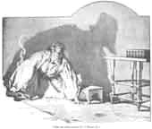
What does God discover when He tries to heal Israel? Have you ever encountered this attitude? Why is impenitent sin so dangerous?

Does God forget our sin? (7:2)

What happens to rulers who use criminals for their purposes instead of stopping the criminals? (6:3-7)

What is the danger of mixing/mingling (like flour & water into dough) ourselves with others who share different beliefs? (6:8)

How is Ephraim (Israel) like a “silly dove”? (7:11) What is the danger in finding help indiscriminately? Who is the only trustworthy source of help?

God, throughout Israel’s history, showed them that they need not rely on outside allies to defend themselves. What is the consequence when they doubt God and make alliances with pagan nations? (7:13-16) How does this lesson in allies apply to the Christian church today?

Willful Idolatry (8:1-14)

What is the “House of the Lord” in 8:1?

In 8:2, Israel calls out to God for salvation, but God is not merciful. Why not?

How does the consequence of their choice of kings compare with our democratic process? (8:4) Have we made “silver and gold idols”?

Why does God reject Samaria’s (the Northern Kingdom’s) sacrifice? (8:5) What does this tell us about our offerings to God?

8:6 shows us the evidence of the people’s hearts: the calf of Samaria. Is it okay to mix pagan worship with worship of the true God?

How is idolatry like sowing wind? (8:7)

In what way is Israel (not Judah) “swallowed up”? (8:8-10)

How were their altars “altars to sins”? (8:11-13) What sacrifices might we make that would be sinful?

Is building palaces a sin? Why would God punish them for that? What kinds of palaces have you built like this for yourself?
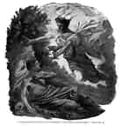
Figure 9: Hosea 8:14

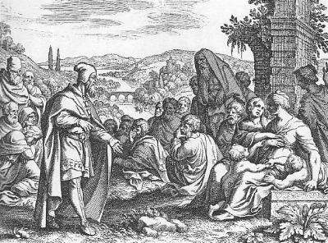
The Judgment of Israel by God (9:1-10:15)
Figure 10: Hosea Weds a Harlot, Matthaeus Merian the Elder, 1625-30

Judgment of Dispersion (9:1-9)

9:1-2 indicate that Israel had a bountiful harvest. Why the command not to celebrate in 9:1?

What “Egypt” (8:13) is Israel taken captive to? (9:3) Note the irony that this was the country with whom they’d formed their unholy alliance.

What is the significance of the lack of sacrifices in 9:4?

What happens when God’s festivals are not celebrated properly? (9:5) Has this happened to any modern holy days?

How does God describe prophets and spiritual men who draw their wisdom from sources besides the true God? (9:7) In our society, many people say, “I’m spiritual but not religious.” How does this passage speak to this statement?

A watchman’s job is to protect the city by watching for danger. How were Israel’s watchmen different? (9:8)

Judgment of Barrenness (9:10-17)

In 9:10, Israel is compared to fruit in the wilderness, a welcome sight, but she quickly changed and became detestable instead. How does God respond their lack of fruitfulness in 9:11-14?

How would childlessness in this case be a good and appropriate thing?

What was so hateful about Gilgal? (cf. 1 Sam 8:5-22) How were their actions in Hosea’s day like those of the events at Gilgal?

What is the purpose of excommunication? Compare 9:17 to the practice of excommunication.

Judgment of Destruction (10:1-15)

What is the usual effect of material wealth on people? (10:1)

Does 10:3 express true repentance?

What are the Israelites upset about in 10:5-6? The calf couldn’t save itself nor the people. How does our trust in Jesus, Who didn’t save Himself from the cross, different?

What is the primary sin that results in judgment from God in 10:7ff?

What is the yoke placed on Ephraim? Why is the nation called “Jacob” here?

Where is the righteousness in 10:12 found?

Why is it appropriate for God to destroy Israel’s army and king? (10:13-15)

The Restoration of Israel to the Lord (11:1-14:9)
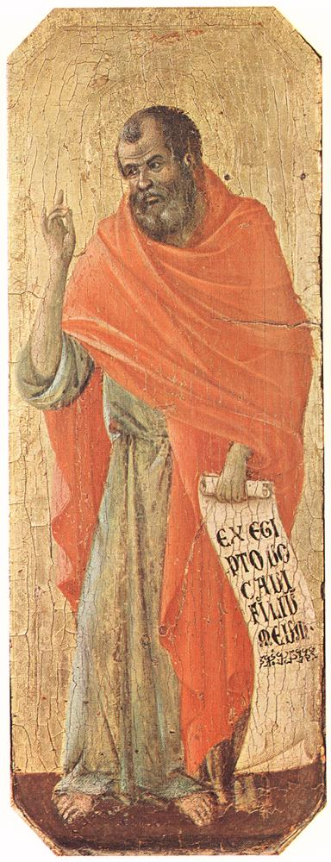
Figure 11: Hosea, Duccio di Buoninsegna, 1308-11

God’s Love for Israel (11:1-12)

Who is the Israel referred to in 11:1?

Who is calling in 11:2?

Has God ever healed you, and you didn’t acknowledge God as the healer?

What is the yoke that God lifted in 11:4? How did God lift it?

What had God done before this punishment to encourage His people to repent? (11:7)

Who are Admah and Zeboiim? (11:8) (q.v. Ge 10:19; De 29:23) What was God contemplating doing to Israel in 11:8?

Why does God relent from destroying Ephraim in 11:8-9?

What is the roar in 11:10? (cf. Rev 5:5)

What causes the people to repent?

In 11:11, we see where they come from, but where do they go?

Note that God promises salvation in 11:9-11 in spite of 11:12. Is God inconsistent?

Israel’s Continuing Sin (12:1-13:16)

What is the “wind” Ephraim feeds on?

What do Jacob’s actions in the womb have to do with Israel in Hosea’s day? (12:3)

In what way should Israel emulate Jacob’s actions as described in 12:4?

Do you ever have trouble waiting for God? How can that cause you to sin?

Does material prosperity indicate a reward for a godly life? (12:8) How does God reward godliness?

Who does Ephraim credit for wealth? How is considered this idolatry?

What do the tents (12:9) signify?

Did God abandon Israel when they were “wandering in tents”? What does this mean for Israel here? What does it mean for us?

What are some common modern “altars” that people find preferable to the altar of Yahweh (12:12)?

What does God say about such altars?

What does Israel’s (Jacob’s) work as a shepherd (Gen 29:16-28) have to do with Israel of Hosea’s day? (12:13)

How does Israel respond? (12:15) What is the result? How is this like a person who rejects God’s love?

What happens when we become self-important? (13:1-3)

Note again how 13:4 speaks to the modern belief that “all religions are basically the same.”
Figure 12: Page from Hosea in Gutenberg Bible

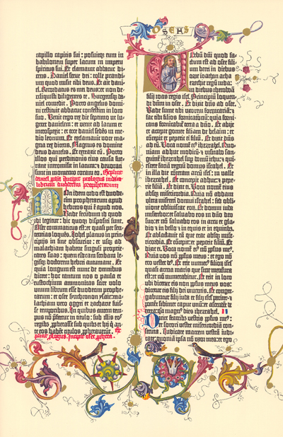
What is the typical human response to God’s blessings? (13:6)

Why does Israel receive God’s wrath? Isn’t He a God of mercy?

How does God, their true King, compare to earthly kings?

What immediately follows God’s wrath (13:14) How is this typical of God?

Note that the 1st two sentences in 13:14 can be translated as either questions or statements. Most translators translate them as questions because of the wrathful context. Is this necessary? How does 1 Cor 15:55 help answer this question?

Note that what is “hidden from My sight” can also be translated “repentance”. How would this be an appropriate translation?

Is wrath absent from the first part of 13:14?

Note in 13:15 that “Ephraim” means “fruitful,” so the passage is a play on that name.

What is the “east wind” in 13:15?

In 13:16, note again that God calls Israel (the Northern Kingdom) “Samaria,” a less honorable name.

God’s Promise to Restore Israel (14:1-9)

Why does God call Israel (note the use of the name) to repent?

On what basis is the request in 14:2-3 made?

Is it sinful to ride horses? (14:3)

What did the people do to earn God’s favor? (14:4)

What is the effect of being rooted in God? (14:5-6)

How does the description in 14:7 affect God’s renown? How do God’s people living godly lives affect God’s renown?

Why doesn’t Ephraim need idols? (14:8)

Who is wise (14:9)? (q.v. Deut 4:3-9)

Why do the righteous walk in God’s ways? (14:9)

Summary Questions

How is Hosea’s time like ours?

How is Hosea’s message particularly applicable to our daily lives?

Why is Hosea relevant to all eras of God’s people?
©2005 Rev. Dale Critchley
lcmspastor.com/pastordale

A Chronology Of Biblical Christianity. by Dr. R.C. Wetzel, 1995.
Pitts Theology Library Digital Image Archive
The Open Bible, Expanded Edition. Thomas Nelson, 1985.
http://www.bible.org/page.asp?page_id=967
The primary source, besides the original text, used in this study guide is the following: Laetsch, Theo. Bible Commentary:The Minor Prophets. 3rd Printing. Concordia Publishing House, St. Louis: 1970.
Pitts Theology Library Digital Image Archive
Ibid.
Web Gallery of Art
The name “Jezreel” means, “God sows.”
Biblical Art on the WWW
Web Gallery of Art

